**Problem 2.21**

**Identifying decision variables**: Let X1, X2 be type 1 and type 2 ores

The cost of type 1 and type 2 ores is $90 and $120, respectively.

Hence the **objective function** is to optimize the function 90X1 + 120X2

**Optimizing:** 90X1 + 120X2

**Identifying Constraints**:

Copper content in type 1 and type 2 ores is 20% and 30% respectively, per ton. Since Blacktop likes to buy ores to extract at least 8 tons of copper,

=> 0.2X1 + 0.3X2 >=8

Zinc content in type 1 and type 2 ores is 20% and 25% respectively, per ton and Blacktop refinery’s lower limit for buying zinc is 6 tons,

=> 0.2X1 + 0.25X2 >=6

Similarly, for magnesium, its 15% and 10% for type and type 2, respectively per ton and 5 tons is the lower limit

=> 0.15X1 + 0.1X2 >=5

The upper and lower bounds would be

X1 >=0 and X2 >=0

Therefore, LP model for Blacktop Refining is as follows

Min: 90X1 + 120X2

Subjected to below constraints

0.2X1 + 0.3X2 >=8

0.2X1 + 0.25X2 >=6

0.15X1 + 0.1X2 >=5

X1 >=0 and X2 >=0

Output from Analytic Solver (Also attached as excel Problem 2.21)

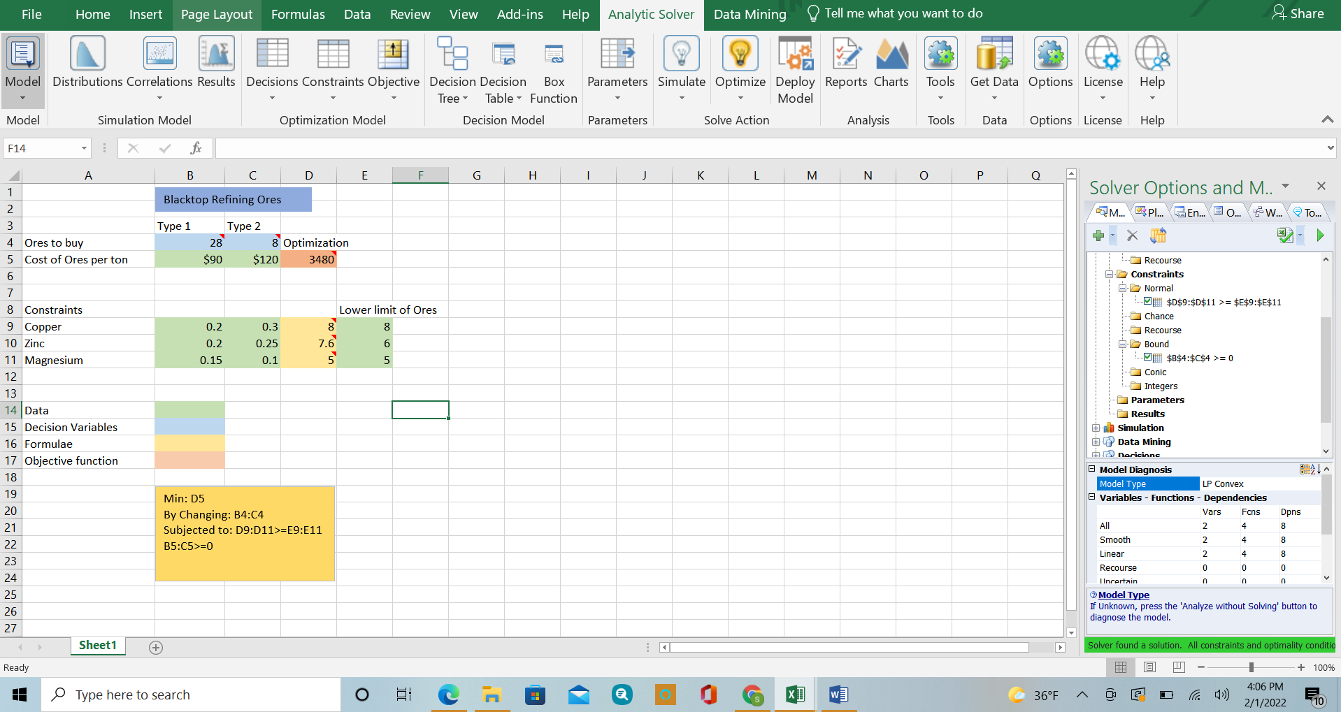

Hence, 28 of type 1 ore and 8 type 2 ore

**Problem 3.22**

**Identifying decision variables**: Let X1, X2, X3, X4, X5, X be the amount of money to be invested in the Bonds A, B, C, D, E respectively

An officer wants to invest $100,000 to maximize the annual returns

Hence the **objective function** is to maximize 0.095X1 + 0.08X2 + 0.09X3 + 0.09X4 + 0.09X5

**maximize** 0.095X1 + 0.08X2 + 0.09X3 + 0.09X4 + 0.09X5

**Identifying constraints**:

The total amount of money is $100,000

=> X1 + X2 + X3 + X4 + X5 = 100000

At least 50% of the money should be in short term issues

=> X2 + X5 >=50,000

No more than 50% in high-risk issues

=> X1 + X4 + X5 <=50,000

At least 30% of the funds should go in tax-free investments

=> X1 + X2 + X4 >=30,000

At least 40% of the total annual return should be tax-free

=> 0.095X1 + 0.08X2 + 0.09X4 >= 0.4(0.095X1 + 0.08X2 + 0.09X3 + 0.09X4 + 0.09X5)

The upper and lower bounds are

=> X1>=0, X2>=0, X3>=0, X4>=0 and X5>=0

Therefore, LP model for Blacksburg National Bank problem is as follows

Max: 0.095X1 + 0.08X2 + 0.09X3 + 0.09X4 + 0.09X5

Subjected to below constraints

X1 + X2 + X3 + X4 + X5 = 100000

X2 + X5 >=50,000

X1 + X4 + X5 <=50,000

X1 + X2 + X4 >=30,000

0.095X1 + 0.08X2 + 0.09X4 >= 0.4(0.095X1 + 0.08X2 + 0.09X3 + 0.09X4 + 0.09X5)

X1>=0, X2>=0, X3>=0, X4>=0 and X5>=0

Output from Analytic Solver (Also attached as excel Problem 3.22)

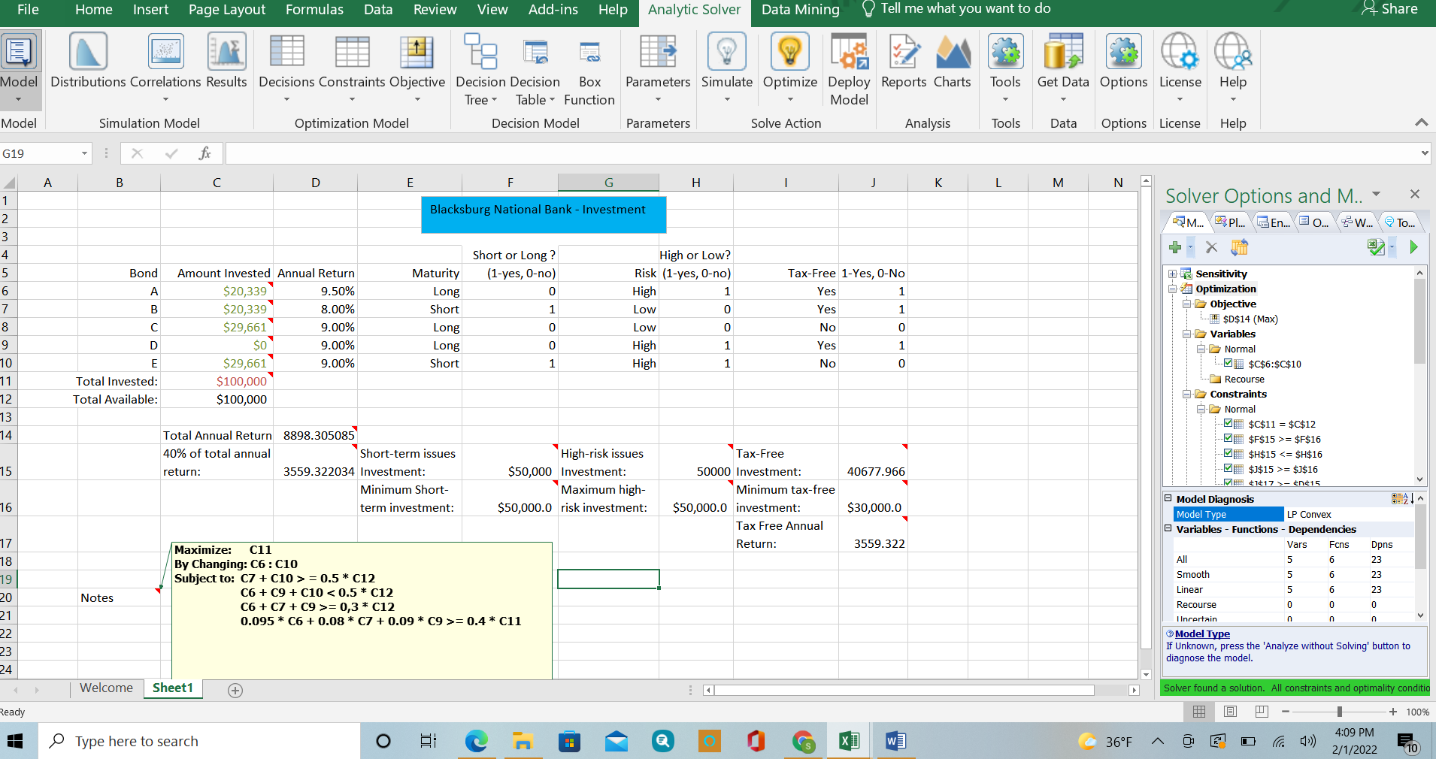

The amount of the money to be invested in each bond are X1=$20,339

X2=$20,339

X3=$29,661

X4=$0

X5=$29,661